**DASHBOARDS AND STORIES**

**DASHBOARD:1**

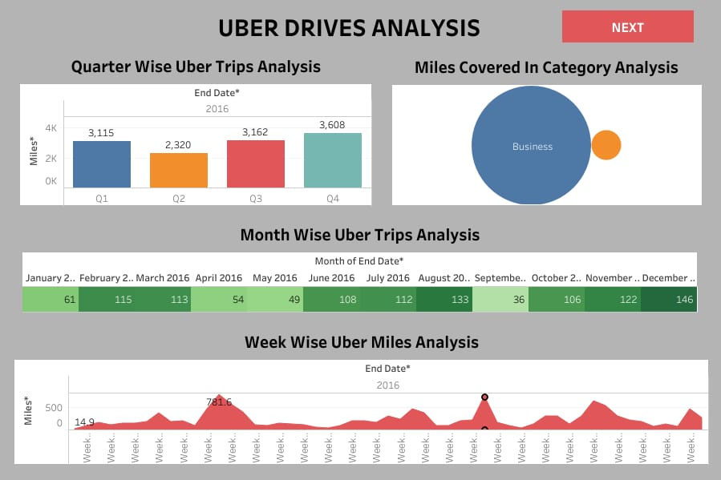

**DASHBOARD:2**

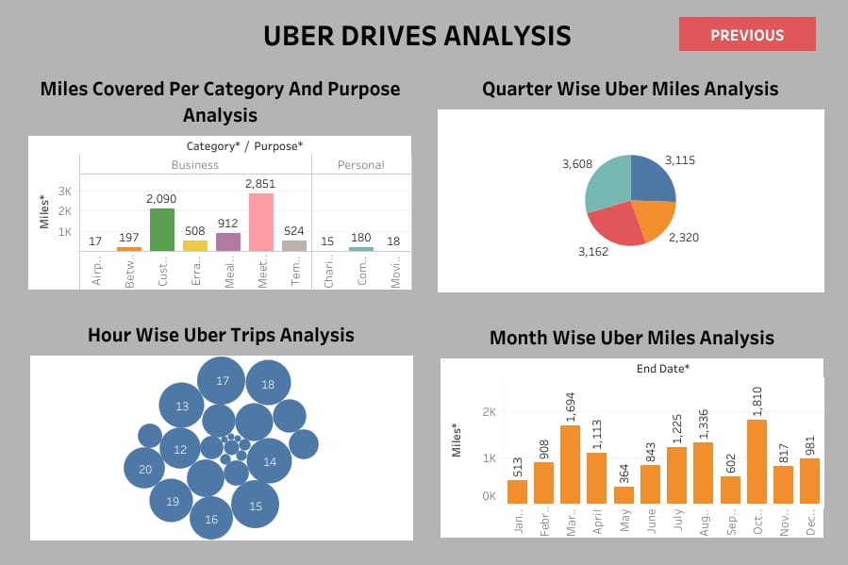

**STORY 1:**

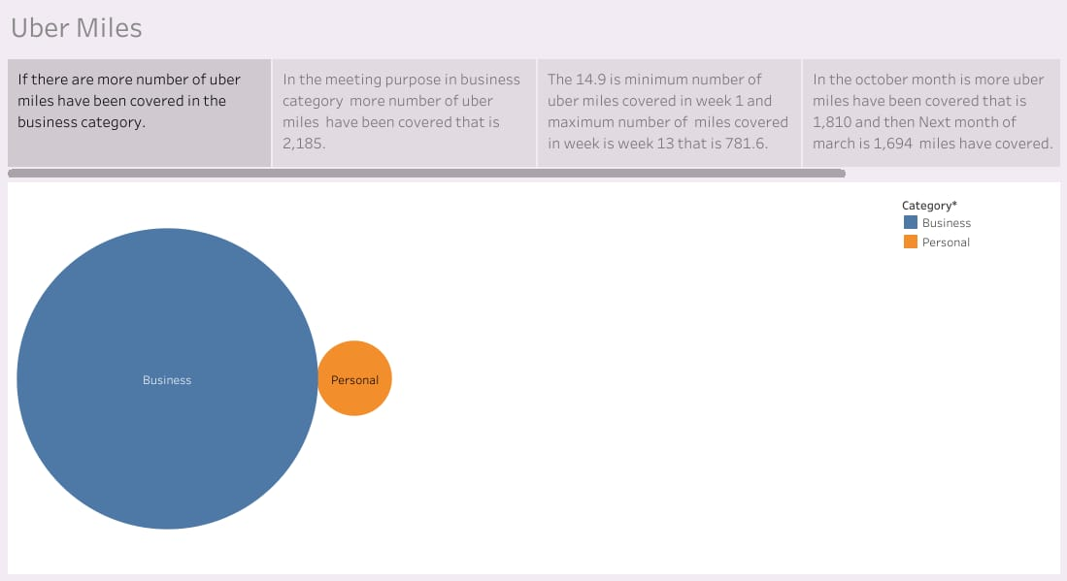

**STORY 2:**

